1. 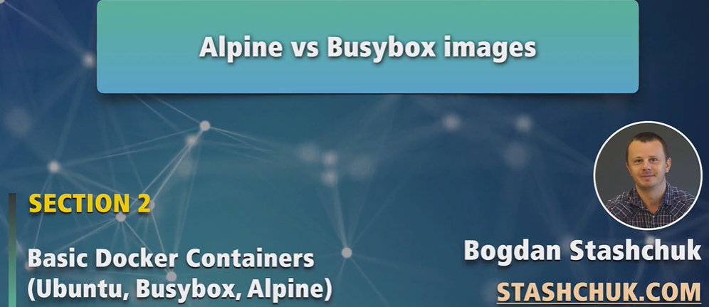
2. Busybox is not full-featured Linux OS.
   1. It is a set of Linux utilities.
3. Let’s just pull Alpine image.
4. 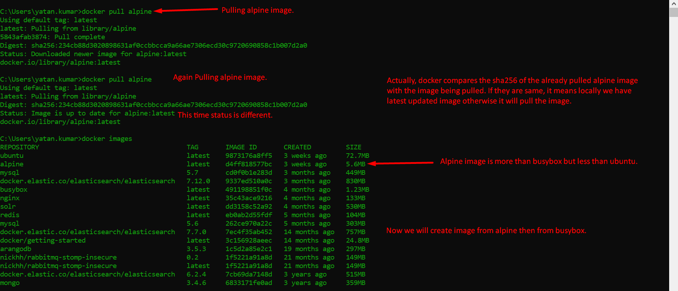
5. **NOTE**: Alpine is based on busy box. We will prove this in this lecture.
6. Busybox is a set of Linux utilities.
   1. Alpine is full-featured Linux having busybox too.
7. **Skipped**